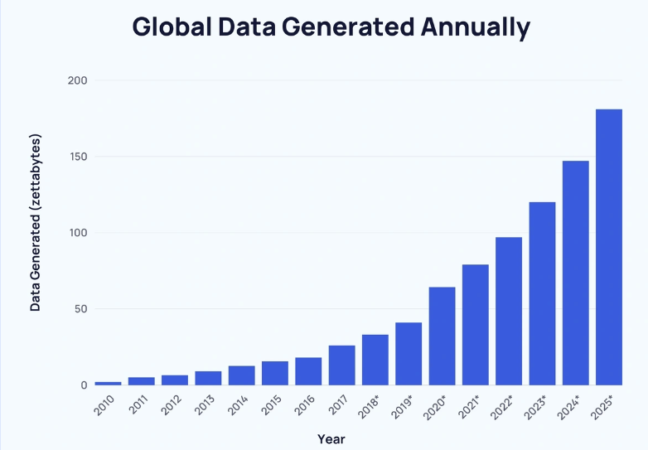
Dive Into Data Through a

STEM Lens!

Did you know that the amount of data we are generating each year is growing faster than most anything on our earth? Who even makes sense of all that data? Data Literacy skills are needed in every aspect of life, education, and work. Children and young adults have an innate ability to recognize patterns; our job is to pique their curiosity as they dive into data!
Graphic from Exploding Topics

This 2-part interactive workshop will explore K-12 lessons that have students collecting and analyzing data that is important to their world and experiences. If dogs have long hair, are they more likely to have curly tails? Does the day of the week impact if a video goes viral? Teachers will experience lessons that dive into these questions and provide you with all the resources to replicate the lesson(s) with your students and experience data in a new way.

Where: Virtual workshop and VERY interactive! This is a 2-part series.

Who: K-12 teachers - focus on math, science, and technology

Workshop #1: Thursdsay Oct 10th 3:45pm – 4:45pm

Workshop #2: Thursday Oct 24th 3:45pm – 4:45pm

Registration Link (once you register the Zoom link will be sent to you)
**Teachers will receive 1 hour of TEAMS STEM credit per session.**

Registration Link through PowerSchool:
https://alsde.truenorthlogic.com/ia/empari/learning2/registration/presentRegistrationDetails/493440
Course # 314412
Section #493440

Questions?
Contact Chet Nicklas
Black Belt STEM Institute Director
cnicklas@uwa.edu

Information for Receiving Hours

Workshop Objectives:
- Learn about Data Science/Literacy that support state standards.
- Learn about using online tools to support collecting and analyzing data.
- Support implementation of collecting and analyzing data within grade-level classrooms.
- Build teacher confidence and learn strategies to create a math class where students are curious and share their math ideas.

Workshop Outcomes:
- As teachers implement data literacy activities, students’ curiosity and engagement will be supported through real-world data collection and data analysis.
- Teachers implementing the data literacy activities will support student engagement in state standards.

Alabama State Standards the Workshop Addresses:
- Data Analysis and Statistics
  - Quantitative Literacy
  - Visualizing and Summarizing Data

